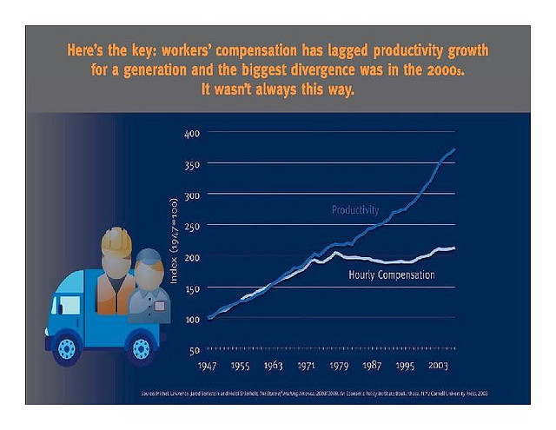

Productivity Wages
See dynamic graph at: http://www.stateofworkingamerica.org/pages/interactive#/?start=1917&end=1961

